
How You Can Help:
- Intervention: Sometimes a confrontation is necessary, and doing so in a group can prove beneficial. Just be careful of the dangers. An addicted person may try to manipulate the intervention into a viewing party. Beware of conversational cues like, “Have you heard the theme song from The Unbreakable Kimmy Schmidt?” or “This is just like that one episode of Friends…”
- Support Groups: Schedule meetings at a church, school, or community center where addicted persons can share their struggles. Just be careful in the meetings to avoid using film quotes or talking about favorite actors.

- Activities: Finding other fun things to do (especially outdoors) can empower people to battle their addictions. Sports and board games not based on movies are good choices. Avoid childhood games like staring contests or Killer’s Wink, as “Blink” is considered the gateway drug to Doctor Who addiction.
- Charity: Some addicts neglect their outside lives to the point of becoming unemployed. Beware of giving them money directly, as such generosity can become enablement. Consider providing meals when necessary or bringing food to scheduled events and activities.
- Optometry: Sometimes just helping someone make an appointment will help to ensure that they don’t suffer long-term vision problems resulting from staring at a screen for prolonged intervals. Taking a friend to the optometrist also gets them out of the house for part of the day.


=




Streaming Media Addiction
and
How You Can Help




Did you know?
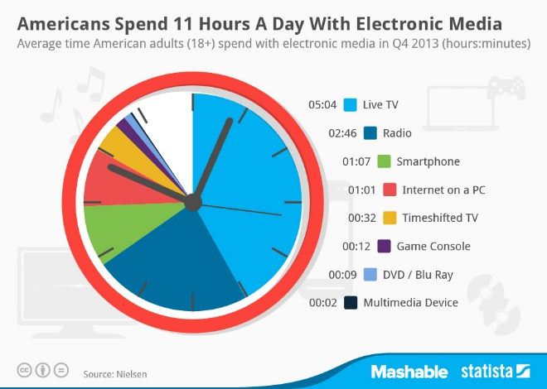

- The average Netflix viewer watches 93 minutes of content per day.
- Netflix’s 40 million users watch a total of one billion hours every month.
- 61% of viewers binge-watch series every few weeks.
(http://www.newsy.com, n.d.)
A small number of users are able to watch only one movie or one episode of a favorite show at a time, but many consume multiple hours of content in one sitting. Some watch entire seasons of favorite shows within a weekend or even a day. A few even spend that time on shows they don’t particularly enjoy.
Getting hooked on streaming video can lead to a number of problems, including difficulties in relationships, forgetting to pay bills, and—in some cases—unemployment.

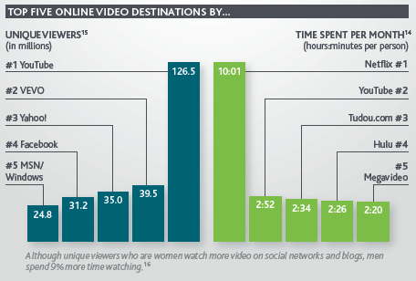
(http://storefrontsocial.com/, 2014)

What to watch for:
- Insomnia: A person addicted to Netflix may spend valuable sleep time trying to catch up on House of Cards in time for the next day’s conversations around the water cooler. Unfortunately, the lack of sleep results in fatigue, low productivity, and an inability to contribute to conversations on any other topic.
- Withdrawal: Too often a person sacrifices social interaction for relationships with fictional characters. While watching Orange Is the New Black a viewer creates her own form of solitary confinement.
- Mood swings: Obsessing over one’s favorite show can lead to anxiety and tension while one awaits new episodes, coupled with angry outbursts when a stream is interrupted or a title becomes unavailable.
- Messy surroundings: Addicts typically neglect responsibilities such as household chores or laundry. They may leave home in dirty clothes, or they may not leave home at all as piles of clutter accumulate around them.
- Extreme weight loss or gain: A person who spends hours hunting ghosts with the Winchester brothers or battling aliens in the TARDIS will often forget to eat meals, or he might consume snacks while watching without giving thought to the quality of food he is eating. This can lead to malnourishment on one hand or obesity and diabetes on the other.


If you witness these signs, someone you know could be suffering from an addiction to Netflix or another streaming service, referred to as netfliction or huluholism. Don’t ignore the symptoms! You can help!

References
State of the media 2011: Offline vs. online viewing. (n.d.). Retrieved June 22, 2015, from http://www.newsy.com/blogs/state-of-the-media-2011-offline-vs-online-viewing/
How are Americans using their electronic media time? – Storefront social. (2014, October 29). Retrieved June 22, 2015, from http://storefrontsocial.com/blog/americans-using-electronic-media-time/

